A Regional Club of the American Brittany Club
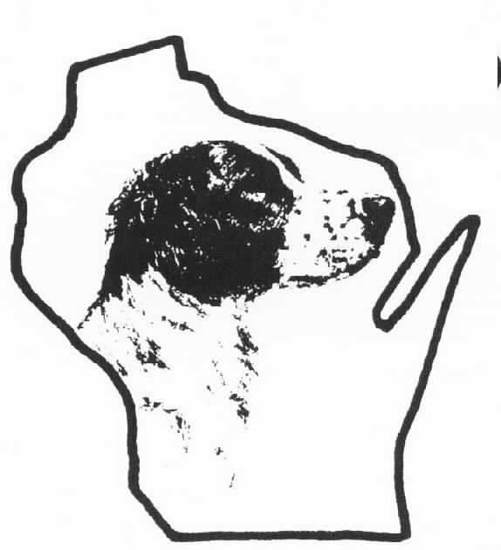
YOU ARE INVITED TO OUR

SPRING HORSEBACK FIELD TRIAL
APRIL 20-21, 2019
LOCATED AT
PINE ISLAND WILDLIFE AREA
PORTAGE, WISCONSIN
THIS IS AN AKC LICENSED TRIAL
AND ALSO IS A SANCTIONED AMERICAN FIELD EVENT

PLEASE NOTE: Your dog does not need to be FDSB registered to compete but he does need to be registered for a placement (1,2 & 3) to be recorded by the American Field, which would allow you to compete in future American Field Championships. If your dog is FDSB registered, please include your dog’s registration number and color on your entry form.
- MEALS-MORNING (COFFEE AND ROLLS) AND LUNCH WILL BE AVAILABLE AT THE HEADQUARTERS BUILDING. BADGER WILL HOST A HAPPY HOUR & DINNER AT THE HEADQUARTERS BUILDING AFTER SATURDAY’S RUNNING
- HANDLER HORSES WILL NOT BE PROVIDED
- CAMPING IS PERMITTED ON THE GROUNDS. SELF-CONTAINED UNITS ONLY-NO TENTS
NO OPEN FIRES
- IN CASE OF EMERGENCY Call Jim Brigham 608-334-3909 (cell)
- AREA MOTELS INCLUDE:
RIDGE MOTOR INN 608 742-5306
SUPER 8 MOTEL 608 742-8330 * Headquarters
DAYS INN 608 742-1554
THE PORTERHOUSE 608 742-2186
BEST WESTERN 608 742-2200
COMFORT SUITES 608 745-4717

ENTRIES MUST BE COMPLETED IN FULL AND SUBMITTED WITH FEES PIOR TO THE DRAWING. COMPLETE ONE ENTRY PREMIUM FOR EACH STAKE RUN PER DOG. MAKE ALL CHECKS PAYABLE TO BADGER BRITTANY CLUB

ENTRIES WILL CLOSE AT 7:00 P.M., MONDAY APRIL 13, 2020
DRAWING WILL BE HELD AT 7:30 P.M., MONDAY APRIL 13.2020
FOR INFORMATION, CONTACT JIM BRIGHAM, FIELD TRIAL SECRETARY AT 608 233-3909
OR jwbrigham03@sbcglobal.net

- HORSES MUST HAVE A CURRENT NEGATIVE COGGINS TEST
- $3.00 PER ENTRY IS PAID TO THE PINE ISLAND GROUNDS ASSOCIATION

Directions
The following directions are for those traveling from the south. The easiest route is to take I90-I94 to I-39 to Hwy 33 East. Exit on Hwy 33 East to Fairfield (Levee) Rd. turn left at Blysone Towing and continue on Fairfield to Statz Rd. Take Statz to the end. This is the location of the Pine Island Hdqtrs. Bldg. and is about 6 miles from Hwy 33-Fairfield intersection.
Big Rigs have found the underpass on Fairfield (Levee Rd.) to be uncomfortably low. They have chosen to continue on I90-I94 to Hwy 33. They exit at Hwy 33 and go west over the Baraboo River. Just past the river, they turn right on Cty Hwy U. They continue north. Where Cty Hwy U junctions with Schepp Rd., they take Schepp Rd. north to Levee (Fairfield) Rd. They turn right on Levee Rd. and travel approximately 4 miles to Statz Rd. Turn right on Statz to the Headquarters Building.
NOTE:
Fairfield Township stretch of Levee Road has a 5 ton limit on it and the does monitor it. Caledonia Township has a 15 ton weight limit.

