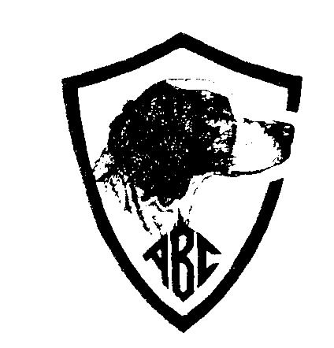

The American Brittany Club, Inc.

Presents


The 2023ABC Grouse & Woodcock Championship
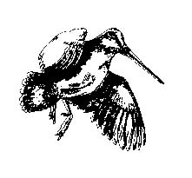
October 11-12, 2023

Hosted by Badger Brittany Club

Grounds: Located northeast of Augusta, WI in the Eau Claire County Forest.
Refer to the enclosed map for more detail.

Entry Fee: $140.00

Accommodations:
Headquarters will be the Woodland Motel (715-286-2112) 11 min north of Augusta on State Hwy 27.
Al’s Pioneer Motel (715-286-5656) in Augusta, WI
Countryside (715-289-4000) in Cadott, WI
Super 8 Motel (715-644-3332) in Stanley, WI
Super 8 Motel (715-597-5000) in Osseo
Airbnb Cooper’s Cabin in Fairchild, WI
https://www.airbnb.ca/rooms/43856358?source_impression_id=p3_1695222224_jQLLAqUb184FJqmV
Camping: Permitted at the Rock Dam County Park. Water, electricity and shower are available.
http://www.co.clark.wi.us/ClarkCounty/Departments/forestryparks/ParksCamp/RockDam.asp
(715) 743-5140 or (715) 267-6845.

Food: To be determined

Awards: AKC standard ribbons and Trophies
ABC Rotating Trophy is housed at the Bird Dog Hall of Fame – Brittany Wing at Junction City, TN. A brass plate will be added to the trophy to commemorate the Winner.

Questions: Contact Jim Brigham 608-233-3909 (h) – 608-334-3909 (c) or jwbrigham03@sbcglobal.net

Sponsored By



